Title: Writing Program Administrators as Diversity Practitioners: Assessing for Institutional Transformation

Introduction

This presentation originates from Kay Halasek’s and my experiences as writing program administrators asked to complete a program assessment of English 2367, a second-level writing course at Ohio State University. 2367 is a research-based writing class, taught in departments across the university and at all Ohio State campuses. The English department offers several decimalized versions of 2367: a rhetoric-based academic writing section and literature, documentary, science and technology, and folklore sections. As part of the general education curriculum, all versions of 2367 meet the written communication level two requirement, which includes oral and visual communication. Most versions of 2367 also meet the “Social Diversity in the United States” requirement, which is the focus of our presentation here.

[Slide 2] Through the process of developing an assessment for the social diversity requirement as part of a University program review, Kay and I came to understand the opportunities and challenges an institutionally-developed social diversity requirement presents to a writing program. In this presentation, Kay and I will discuss

- The general background of writing programs and diversity initiatives located in the larger social world of higher education institutions,
- The institutional context of our writing program, the “social diversity in the United States” general education requirement, and our assessment process and findings, and
- Our local responses to the findings of the diversity assessment

We will then conclude by articulating

- The continuing areas of inquiry and activism that our experiences suggest to us are those that WPAs at all institutions might pursue

Diversity and Writing Programs Background [Kaitlin]

[Slide 3] I want to take just a moment to talk about the role of diversity in higher education institutions and, more specifically, in writing programs.

Diversity matters in higher education. The American Council on Education summarizes several of these reasons in a statement “On the Importance of Diversity in Higher Education.” Diversity

- Enriches the educational experience
- Promotes personal growth- and a healthy society
- Strengthens communities and the workplace
- Enhances America’s economic competitiveness

As these justifications for diversity suggest, diversity is a means to an end: Fostering diversity is a means to achieving a desired end of health, strength, and economic prosperity.

Other research also demonstrates that diverse groups produce more innovative, creative, and better quality results (Phillips 2014), and diverse educational contexts enhance student problem-solving and increase tolerance for difference (Terenzini et al 2001).

[Slide 4] However, it is also important to pay close attention to how institutions promote and deploy “diversity” in strategic ways. In On Being Included: Racism and Diversity in Institutional Life, Sara Ahmed questions institutional structures and practices related to diversity and whether these structures and practices serve liberatory purposes. Ahmed suggests that diversity is a performative action in higher education institutions: By establishing an office of diversity, a diversity general education requirement, or claiming the institution as a diverse space, then diversity, or at least its appearance, has been achieved. Substantial institutional rarely change occurs. Ahmed argues that diversity work can transform institutions, that by coming up against the limits and impasses, the brick walls, of diversity in higher education institutions, these institutional understandings and commitments to diversity become visible. Once the boundaries are visible, they can be transformed. But to transform institutions, we must be diversity practitioners.

[Slide 5] I want to suggest that as writing program administrators we in many ways already are diversity practitioners, or if we are not already, we should be diversity practitioners. Many scholars in writing studies and writing program administration have done diversity work such as mapping institutional structures and considering ways that instructors and administrators can transform them. For example, Asao Inoue’s work on anti-racist writing assessment addresses the white racial habitus of higher education institutions and more specifically, the writing classroom. He proposes anti-racist classroom assessment practices as one way to begin breaking down the white racial habitus. Philip Marzluf details how the writing program at Kansas State was redesigned as an “introduction to diversity-based writing” to better enhance campus diversity. There has been a significant body of work on linguistic diversity in writing classrooms and programs. The work of these scholars is valuable. However, this work also primarily focuses on individual writing classrooms or writing programs, rarely addressing how these classrooms and programs are located within a larger institution, with its own structures and practices related to diversity. As writing program administrators, we occupy a unique position of mediating individual classrooms, writing programs, academic departments, and administrative offices. In this position, we need to extend our reach beyond the individual classrooms and our immediate writing program to pay attention to other institutional structures and practices related to diversity.

As diversity practitioners, writing program administrators we must also respond to local institutional structures and practices related to diversity. Specifically, we need to question how diversity is deployed in the white racial habitus of higher education institutions. Does the institution incorporate diversity in service to a white racial habitus, or is the institution committed to transformation through diversity? In the rest of this presentation, Kay and I will discuss how we as WPAs in the second-year writing program came up against an institutional mandate to assess a general education social diversity requirement, and how through the process discovered the need to transform the institutional understanding of social diversity.

Ohio State Social Diversity Background

[Slide 6] The origins of Ohio State’s specific social diversity general education requirement begin in the late 1980s. The general education redesign was intended to create a cohesive curriculum based on “what an educated person should know and be able to do”, including “write and speak with precision, reason logically, and be well-versed in the sciences and liberal arts”. According to the curriculum committee, an educated person should also recognize the pluralistic nature of American society (both historically and currently) and appreciate global and national cultural traditions. In an interim report in 1987, the committee justified the inclusion of social diversity in the general education curriculum, writing,

... appreciation is crucial for at least two reasons. First, we can understand fully our own culture and institutions only if we appreciate the diversity and pluralism which mark our nation. Second, our role in a world characterized by global interdependence requires an understanding of other cultures. … It is important that educated people understand the significance of cultural differences within their nation” (The Lantern, 2-S, Special Supplement, Undergraduate Curriculum Interim Report)

[Slide 7] The general education curriculum, which was instituted in 1988 and continues unchanged today, includes the following requirement for “Social Diversity in the United States.” “Students understand the pluralistic nature of institutions, society, and culture in the United States and across the world in order to become educated, productive, and principled citizens.” The expected learning outcomes for this requirement are as follows:

- Students describe and evaluate the roles of such categories as race, gender and sexuality, disability, class, ethnicity, and religion in the pluralistic institutions and cultures of the U.S.
- Students recognize the role of social diversity in shaping their own attitudes and values regarding appreciation, tolerance, and equality of others.

Let’s pay close attention to the language here. The requirement includes language about appreciation and tolerance. It does not move beyond appreciation and tolerance for diversity education, as Sonia Nieto argues diversity education should. In critiquing such approaches to diversity programming, she describes “appreciation and tolerance” as a “superficial ‘bandaid’ or a ‘feel-good’ addition” to curriculum that allows for the recognition of difference but still maintains the status quo. Instead, Nieto proposes a four-level model of diversity education: tolerance; acceptance; respect; and affirmation, solidarity, and critique--a model that we recognize in retrospect, did not reflect the institutional understanding at Ohio State nor our mandate as a program to deploy the GE requirement.

Now, I turn to Kay, who will describe the assessment process and findings.

Assessment Process and Findings [Kay]

Most of the English 2367 sections offered each semester at Ohio State meet the “Social Diversity in the United States” general education (GE) requirement that Kaitlin outlined above. Always a challenging element in teaching 2367, the social diversity GE requirement (along with the other GE requirements fulfilled by the course--second-level writing and oral and visual communication) was slated for program review in 2015. In December 2014, the Second-Year Writing Program (SYWP) was charged by the College of Arts & Science Curriculum and Assessment to assess each of the GE expected learning outcomes attached to ENGL 2367 and create a report by June 2015. Notably, the 2367 assessment was the first time that the “Social Diversity” learning outcome was to be assessed across the entire university since its implementation in 1988.

With little time to develop an instrument (roughly one month) and even less guidance from the committee (which encouraged programs to create their own direct measures of the GE requirements), we set out to identify the most effective means of assessing social diversity, settling on a pre-post survey/quiz instrument that asked questions directly related to the two learning outcomes mentioned earlier:

- Students describe and evaluate the roles of such categories as race, gender and sexuality, disability, class, ethnicity, and religion in the pluralistic institutions and cultures of the U.S.
- Students recognize the role of social diversity in shaping their own attitudes and values regarding appreciation, tolerance, and equality of others.

[Slide 8] Collaborating with the writing program coordinators on each of the four regional campuses offering the course (as this was to be a University-wide review), we created a three-item rubric that included a course-specific outcome related to the content of our SYW courses:

ELO1a: Students describe and evaluate the roles of such categories as race, gender, ethnicity, and religion in the pluralistic institutions and cultures of the United States
ELO1b: Using specific examples, students describe and evaluate how diversity functions in or is constitutive of literary, cinematic, and/or public discourse.
ELO2: Students recognize the role of social diversity in shaping their own attitudes and values regarding appreciation, tolerance, and equality of others.
The rubric aligned with the “Benchmark-Milestones-Capstone” scale used in the AAC&U rubrics and roughly corresponded with a four-year pathway or development of a particular GE over a student's undergraduate career. So, for example, with respect to item 2, we might expect students to "articulate[ ] a general understanding that literary, cinematic, scientific and technical, or public texts are informed by or constitutive of social diversity" and move through other levels, reaching Level 4, at which point they can "articulate[ ] through a detailed and extended example (or examples) an understanding of the role(s) diversity plays in the construction and/or reception of literary, cinematic, scientific and technical, or public texts" by the senior year.

As a developmental model, the rubric seemed to us a reasonable forecasting of how students might mature or make more complex their understanding of how social diversity functions and their engagements and relationships with it. However, even as we were developing, administering, and analyzing the data from the surveys, we questioned both the reliability and validity--as well as the goals and outcomes--of the survey and its measurements.

[Slide 9] In May 2015, a group of trained readers assessed the social diversity surveys, and an independent statistical consultant analyzed the results. The results, perhaps unsurprisingly, were not significant: Diversity pre- and post-surveys revealed no statistically significant change in two of three criteria; analysis of the first criterion (“Students describe and evaluate the roles of such categories as race, gender, ethnicity, and religion in the pluralistic institutions and cultures of the United States”) revealed a slight statistically significant decrease in student performance.
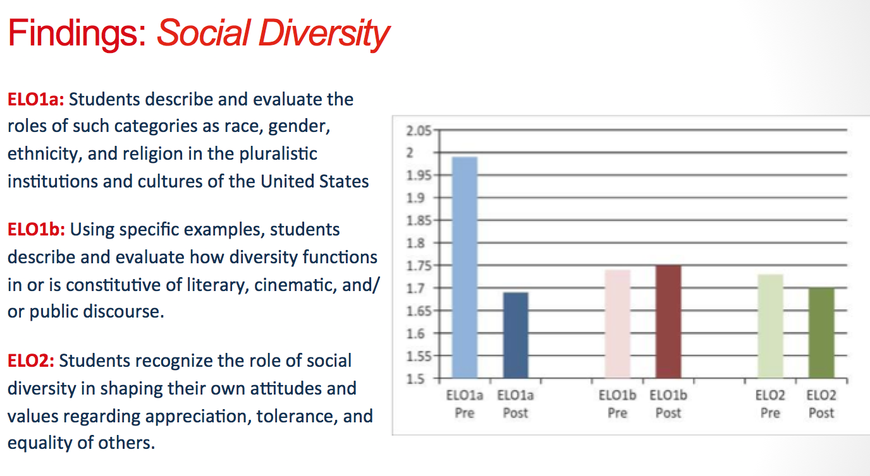
In the 2015 report, we sought to move beyond the quantitative (simply measuring and reporting students’ performances in the aggregate) to the responsive, developing a program enhancement implementation plan that focused on revising curriculum, enhancing professional development, innovating pedagogies, and refining assessment practices.

[Slide 10] In the end, the program review and our report to the GE Assessment Committee were enthusiastically applauded. However, the process of assessment raised for us considerable and numerous concerns and questions regarding both the social diversity GE itself and our assessment of it. And it’s these questions that continue to inform our reflective assessment practice:

- What is or should be the goal of a diversity learning objective?
- How--or, simply--can we reliably assess “social diversity” as a learning objective?
- What does it mean for a writing program to be the (primary) location for a diversity requirement?
- How might we, as writing program administrators, be more responsive to and provide more meaningful leadership with respect to how the University defines, articulates, and characterizes “social diversity”?
- In other words, what does it look like for a writing program to move from functioning as an arm of the institution that simply incorporates diversity in service to a white racial habitus to a program that supports an institution committed to transformation through diversity?

Conclusion: Reflections on the Process and Outcomes [Kay & Kaitlin]

[Slide 11] The assessment of the general education social diversity in the United States requirement has allowed us to turn our attention not to the student relative success or failure on a particular assessment (whether a student moves from “Benchmark” to “Capstone” in four years) but to our diversity learning outcomes and assessment processes. Typically, we would respond to program assessment (in fact, as we did in our 2015 report) by focusing on improving student performance on the assessment by refining the program curriculum, improving instructor training, and innovating our pedagogies.

However, this assessment has prompted us to look beyond student performance in our writing programs to instead focus on the role diversity could and should play in writing programs and higher education institutions. For us, the social diversity assessment has affirmed the need for writing program administrators to advocate for and create meaningful diversity educational opportunities that can contribute to institutional transformation, not simply maintain the status quo of a white racial habitus.

As diversity practitioners, we recognize two local contexts where we must simultaneously advocate and agitate for transformation through diversity: our immediate writing program and the larger institution.

With respect to our writing program, we have moved beyond simple, visible curricular responses (e.g., adding more authors of color to the curriculum) and toward more complex, culturally-responsive understanding of diversity; in other words, moving from an additive approach towards social action. In doing so, we have adopted Sonia Nieto’s four-level model of diversity education (tolerance; acceptance; respect; and affirmation, solidarity, and critique), seeking to move our instruction and assessments from tolerance and acceptance (acknowledging difference and the importance of difference) toward affirmation, solidarity, and critique based in equity and social justice. We can think of Nieto’s model as a developmental model of diversity; students must develop diversity knowledge and practices of these four levels in order to transform society, but for that to happen, we must offer education beyond tolerance and acceptance.

The social diversity requirement as currently conceived at Ohio State is only in the first and second levels of diversity education (tolerance and acceptance). Ahmed’s work on diversity in higher education institutions demonstrates that social diversity requirement is not intended to transform the institution. The current requirement is an additive approach to multicultural education that does not require the university to transform its structure or practices or to transform the students themselves; instead, the current requirement exemplifies the university’s commitment to diversity as long as it maintains the social status quo of a white racial habitus.

It’s not enough that students should tolerate or appreciate diversity; instead, we want students also to practice affirmation, solidarity, and critique. This model of diversity education is foundational to our administrative and pedagogical practices. However, we also recognize that this model must always be implemented with attention to local contexts--and that the contexts in which you administer your programs are perhaps very different from ours.

With respect to the larger institutional context, we recognize our personal and programmatic responsibilities as diversity practitioners and advocates. However, we are also reminded of Ahmed’s argument that diversity is a performative action in higher education institutions. We resist the notion that by establishing an office of diversity, a diversity general education requirement, or claiming the institution as a diverse space that the University (and, by extension, our writing program) has met its obligation to diversity, as no institutional change occurs or is even intended in these actions. To achieve the kind of transformational ends Ahmed envisions, we must make visible (in our training of teachers, our curricula, and our program assessments) the very challenges, inequalities, and injustices diversity work seeks to unveil and address. As Kaitlin mentioned earlier, “Once the boundaries are visible, they can be transformed. But to transform institutions, we must be diversity practitioners.”

[Slide 12] Although, in our case, the SYWP is a primary point of delivery for the social diversity requirement, it is not the only point of delivery. The requirement resides in nearly two dozen other second-level writing courses (and another two dozen or so other non-writing courses) across the curriculum. So, focusing only on affecting change in our one program does little (if anything) to address the larger, institutional assumptions about and pedagogical engagements with social diversity. Given that, we must extend our vision to the larger context, seeking our own opportunities as writing program administrators for affirmation, solidarity, and critique. These opportunities, always, are local, but the following strike us as meaningful actions WPAs at all institutions might consider:

- Be aware of what the institution is doing with respect to diversity and recognize local points of tension and moments of resistance as locations from which to begin activism
- Conduct an initial diversity inventory of university stakeholders (including students, faculty, staff, administrators, and institutional structures) to determine previous experiences, current practices, and short and long-term goals related to diversity
- Work with other programs, departments, student organizations, and other groups to build coalitions to advocate for and affect institutional transformation
- Be an active ally for diversity across the institution and profession

Through our experience developing, assessing, and responding to an institutional social diversity general education requirement, we are committed to transforming our institution as writing program administrators and diversity practitioners. We hope that during the Q&A we can continue brainstorming ways that WPAs can act as effective diversity practitioners to transform our own writing programs and higher education contexts.

